**ASSIGNMENT (MORE ON CSS)**

**1) Create a navigation bar similar to the below-mentioned image. The navigation bar must contain 5 navigation links that are properly placed within the navigation bar using the CSS box model. The navigation items must change their text color on hover.**

**Solution:-**

**<!DOCTYPE html>**

**<html lang="en">**

**<head>**

**<meta charset="UTF-8" />**

**<meta http-equiv="X-UA-Compatible" content="IE=edge" />**

**<meta name="viewport" content="width=device-width, initial-scale=1.0" />**

**<title>Navigation Bar</title>**

**<style>**

**nav {**

**background-color: cornflowerblue;**

**padding: 20px;**

**}**

**a {**

**font-size: 21px;**

**color: #fff;**

**margin-right: 15px;**

**margin-left: 15px;**

**}**

**a:hover {**

**color: #330707;**

**}**

**</style>**

**</head>**

**<body>**

**<nav>**

**<a href="#">Home</a>**

**<a href="#">About Us</a>**

**<a href="#">Contact</a>**

**<a href="#">Blog</a>**

**<a href="#">Login</a>**

**</nav>**

**</body>**

**</html>**

**OUTPUT:-**

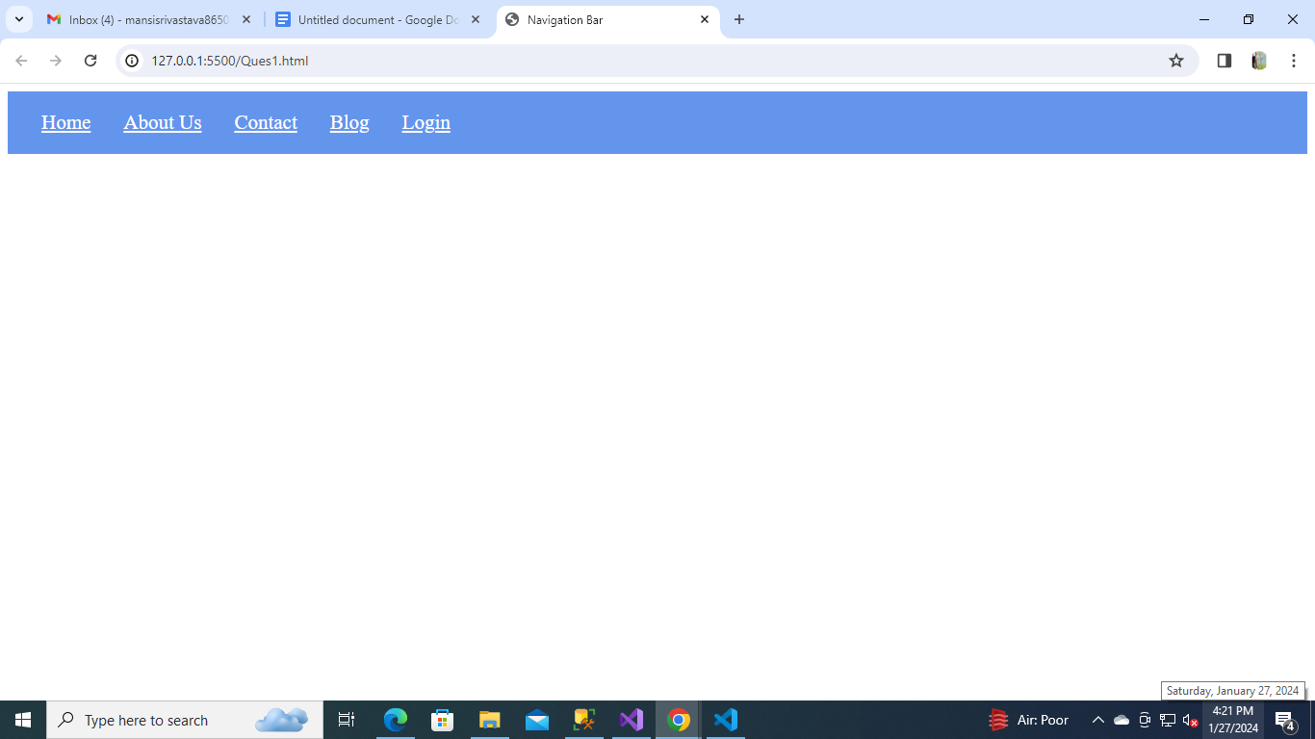

**2) Create a div centered with an image and paragraph similar to the image mentioned below.**

**Solution:-**

**<!DOCTYPE html>**

**<html lang="en">**

**<head>**

**<meta charset="UTF-8" />**

**<meta http-equiv="X-UA-Compatible" content="IE=edge" />**

**<meta name="viewport" content="width=device-width, initial-scale=1.0" />**

**<title>Card</title>**

**<style>**

**img {**

**height: 200px;**

**width: 350px;**

**border-radius: 20px;**

**}**

**div {**

**margin: 0 auto;**

**background-color: #f8c42e;**

**width: 350px;**

**padding: 10px;**

**border-radius: 20px;**

**}**

**</style>**

**</head>**

**<body>**

**<div>**

**<img src="https://cdn.pwskills.com/assets/uploads/thumbnails/6568179250c244fbec73aaf4.jpg" alt="PW Skills Full stack web development" />**

**<p>**

**<b>Course Name:</b>PW SKills full stack web development**

**</p>**

**</div>**

**</body>**

**</html>**

**OUTPUT:-**

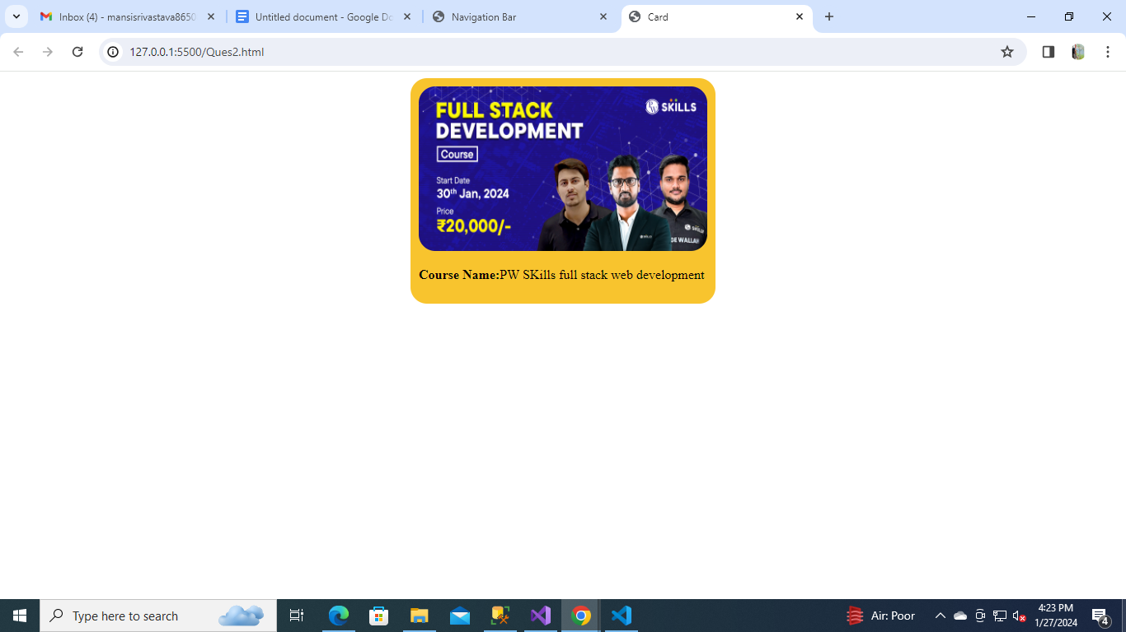

**3) Create a navigation bar similar to Question 1.For each navigation item, use a different border style.**

**Solution:-**

**<!DOCTYPE html>**

**<html lang="en">**

**<head>**

**<meta charset="UTF-8" />**

**<meta http-equiv="X-UA-Compatible" content="IE=edge" />**

**<meta name="viewport" content="width=device-width, initial-scale=1.0" />**

**<title>Navigation Bar</title>**

**<style>**

**nav {**

**background-color: cornflowerblue;**

**padding: 20px;**

**}**

**a {**

**color: #fff;**

**margin-right: 20px;**

**margin-left: 20px;**

**}**

**a:hover {**

**color: #000;**

**}**

**.nav-1 {**

**border: 3px solid rgb(219, 31, 31);**

**padding: 5px;**

**}**

**.nav-2 {**

**border: 3px dotted rgb(94, 86, 86);**

**padding: 5px;**

**}**

**.nav-3 {**

**border: 3px dashed rgb(3, 43, 43);**

**padding: 5px;**

**}**

**.nav-4 {**

**border: 3px double rgb(136, 112, 112);**

**padding: 5px;**

**}**

**.nav-5 {**

**border: 3px groove rgb(0, 0, 0);**

**padding: 5px;**

**}**

**</style>**

**</head>**

**<body>**

**<nav>**

**<a href="#" class="nav-1">Home</a>**

**<a href="#" class="nav-2">About Us</a>**

**<a href="#" class="nav-3">Contact</a>**

**<a href="#" class="nav-4">Blog</a>**

**<a href="#" class="nav-5">Login</a>**

**</nav>**

**</body>**

**</html>**

**OUTPUT:-**

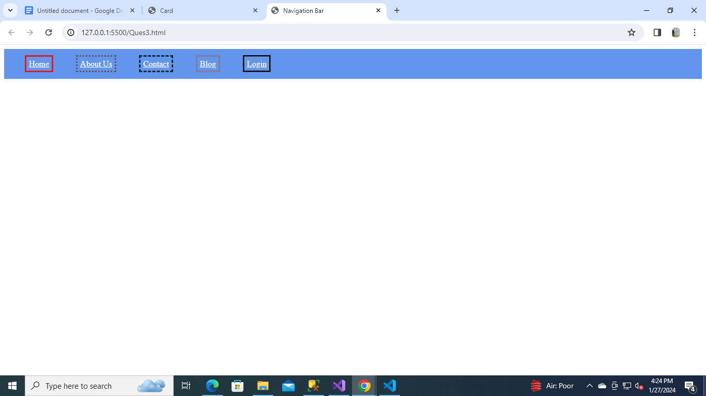

**4) Create a simple webpage with an image and make the image circular using border-radius.**

**Solution:-**

**<!DOCTYPE html>**

**<html lang="en">**

**<head>**

**<meta charset="UTF-8" />**

**<meta http-equiv="X-UA-Compatible" content="IE=edge" />**

**<meta name="viewport" content="width=device-width, initial-scale=1.0" />**

**<title>Circular Image</title>**

**<style>**

**img {**

**border-radius: 50%;**

**background-color: #312ec7;**

**}**

**</style>**

**</head>**

**<body>**

**<div>**

**<img src="./image1.jpg" alt="img">**

**</div>**

**</body>**

**</html>**

**OUTPUT:-**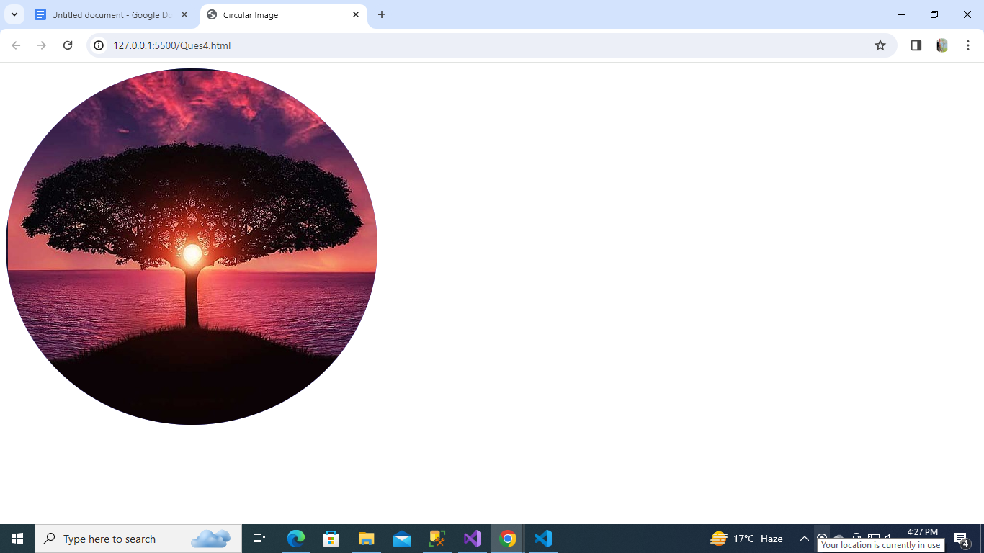

**5) Create a simple blog website about Google fonts. The webpages must have the heading with “Oswald” font align center to the page, below the heading have an image of Google fonts and a paragraph about Google fonts in font “Montserrat” paragraph font style should be “Montserrat” font.**

**Solution:-**

**<!DOCTYPE html>**

**<html lang="en">**

**<head>**

**<meta charset="UTF-8" />**

**<meta http-equiv="X-UA-Compatible" content="IE=edge" />**

**<meta name="viewport" content="width=device-width, initial-scale=1.0" />**

**<title>Google Fonts</title>**

**<style>**

**@import url("https://fonts.googleapis.com/css2?family=Montserrat:wght@300&family=Oswald:wght@500&display=swap");**

**div {**

**margin: 20px;**

**text-align: center;**

**}**

**h1 {**

**text-align: center;**

**font-family: "Oswald", sans-serif;**

**}**

**img {**

**width: 450px;**

**}**

**p {**

**text-align: left;**

**font-family: "Montserrat", sans-serif;**

**}**

**ul {**

**text-align: left;**

**}**

**</style>**

**</head>**

**<body>**

**<div>**

**<h1>Google Fonts</h1>**

**<img src="./google_font_img.png" alt="Google Fonts" />**

**<p>**

**Google Fonts are a collection of high-quality web fonts for use on web projects. Additionally, all fonts can**

**be downloaded for installation on local systems. Fonts are pulled into your website through Google’s content**

**delivery network (CDN) and will load automatically once installed.**

**<br>**

**Google Fonts makes it easy to bring personality and performance to your websites and products. Our robust**

**catalog of open-source fonts and icons, makes it easy to integrate expressive type and icons seamlessly—no**

**matter where you are in the world.**

**</p>**

**<p>**

**Google Fonts (formerly known as Google Web Fonts) is a computer font and web font service owned by Google.**

**This includes free and open source font families, an interactive web directory for browsing the library.**

**Google Fonts is also used With the Google Workspace (Such as Docs, Sheets, Drawings and Slides).**

**</p>**

**<p>**

**Some Commonly used Google fonts are:-**

**<br>**

**Roboto,**

**Open Sans,**

**Montserrat,**

**Lato,**

**Poppins,**

**Source Sans Pro**

**</p>**

**</div>**

**</body>**

**</html>**

**OUTPUT:-**

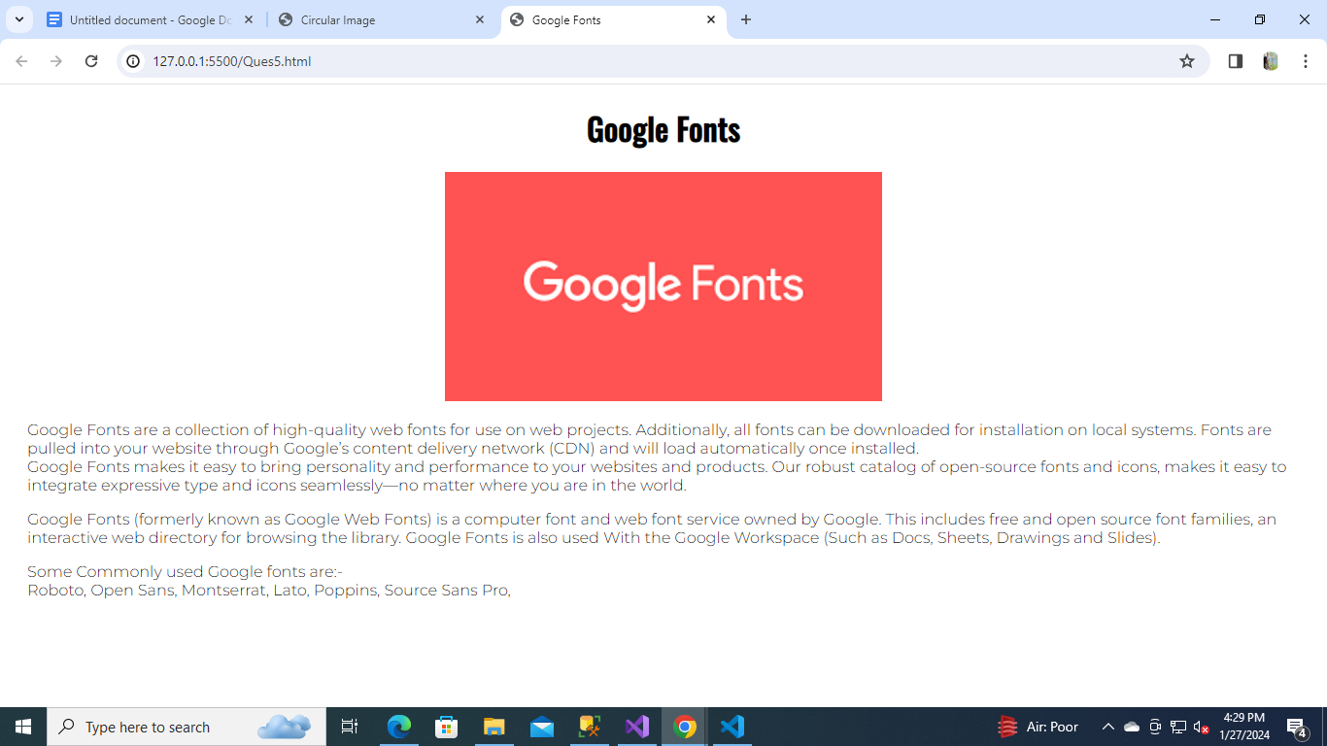

**6) Create a simple website as mentioned in the below image. You can get the assets by visiting** [**https://pwskills.com/about-us/**](https://pwskills.com/about-us/) **.**

**Solution:-**

**<!DOCTYPE html>**

**<html lang="en">**

**<head>**

**<meta charset="UTF-8" />**

**<meta http-equiv="X-UA-Compatible" content="IE=edge" />**

**<meta name="viewport" content="width=device-width, initial-scale=1.0" />**

**<title>About Us</title>**

**<style>**

**@import url("https://fonts.googleapis.com/css2? family=Poppins:wght@200; 400; 500&display=swap");**

**body {**

**text-align: center;**

**font-family: "Nunito Sans",sans-serif;**

**}**

**h1 {**

**font-family: "Poppins", sans-serif;**

**font-weight: bold;**

**font-size: 40px;**

**}**

**p {**

**text-align: justify;**

**padding: 10px 10%;**

**font-size: 1rem;**

**line-height: 1.5rem;**

**color: rgb(61 61 61/var(--tw-text-opacity));**

**}**

**</style>**

**</head>**

**<body>**

**<h1>About us</h1>**

**<p>PW Skills' mission is to permeate through every student/professional's outlook towards jobs and change their attitude and perspective from "How Can I Do It?" to "Of Course I Can Do It". We aim to do this by providing exceptional upskilling courses at affordable rates, while being tech-forward so anyone, anywhere can access and improve their ability to be successful in life.**

**</p>**

**<img src="https://pwskills.com/images/aboutUs/aboutUs.png" alt="about us Image" />**

**</body>**

**</html>**

**OUTPUT:-**

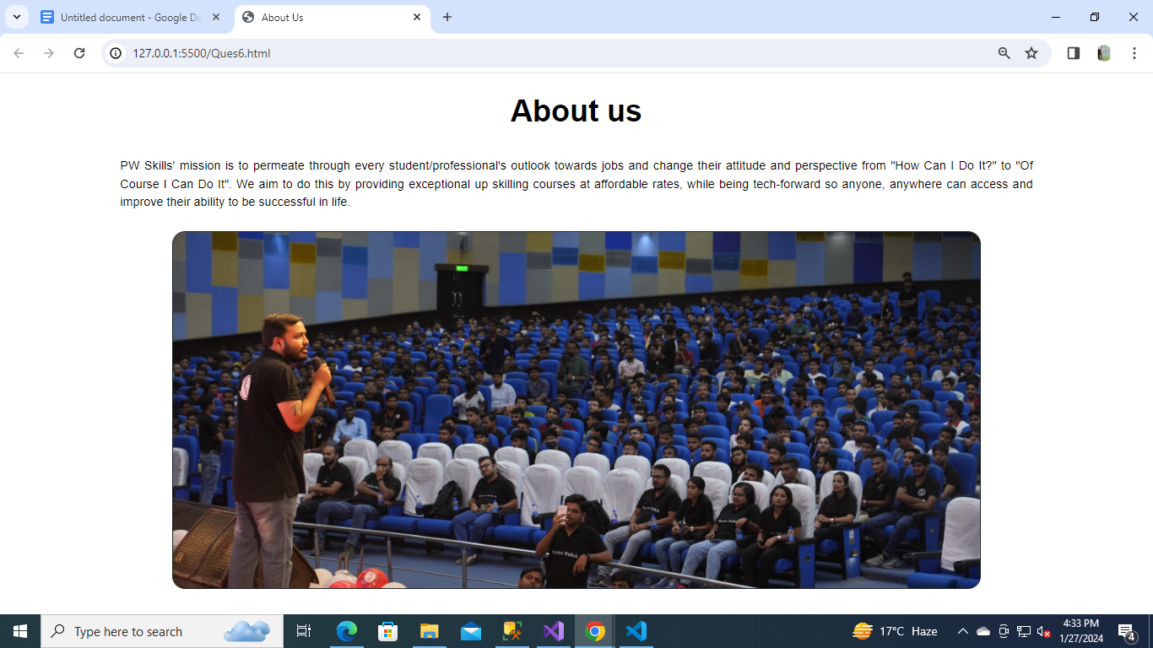

**7) Create a simple webpage with a card similar to question 2. The card must be semi-transparent as default and on hovering the card must be displayed clearly. Use CSS opacity to achieve this output.**

**Solution:-**

**<!DOCTYPE html>**

**<html lang="en">**

**<head>**

**<meta charset="UTF-8" />**

**<meta http-equiv="X-UA-Compatible" content="IE=edge" />**

**<meta name="viewport" content="width=device-width, initial-scale=1.0" />**

**<title>Card</title>**

**<style>**

**.courseImage {**

**height: 200px;**

**width: 350px;**

**border-radius: 20px;**

**}**

**div {**

**margin: 0 auto;**

**background-color: #f8c42e;**

**width: 350px;**

**padding: 10px;**

**border-radius: 20px;**

**opacity: 0.5;**

**}**

**div:hover {**

**opacity: 1;**

**}**

**</style>**

**</head>**

**<body>**

**<div>**

**<img class="courseImage" src="https://cdn.pwskills.com/assets/uploads/thumbnails/6568179250c244fbec73aaf4.jpg" alt="Image" />**

**<p><b>Course Name:</b> PW SKills web development</p>**

**</div>**

**</body>**

**</html>**

**OUTPUT:-**

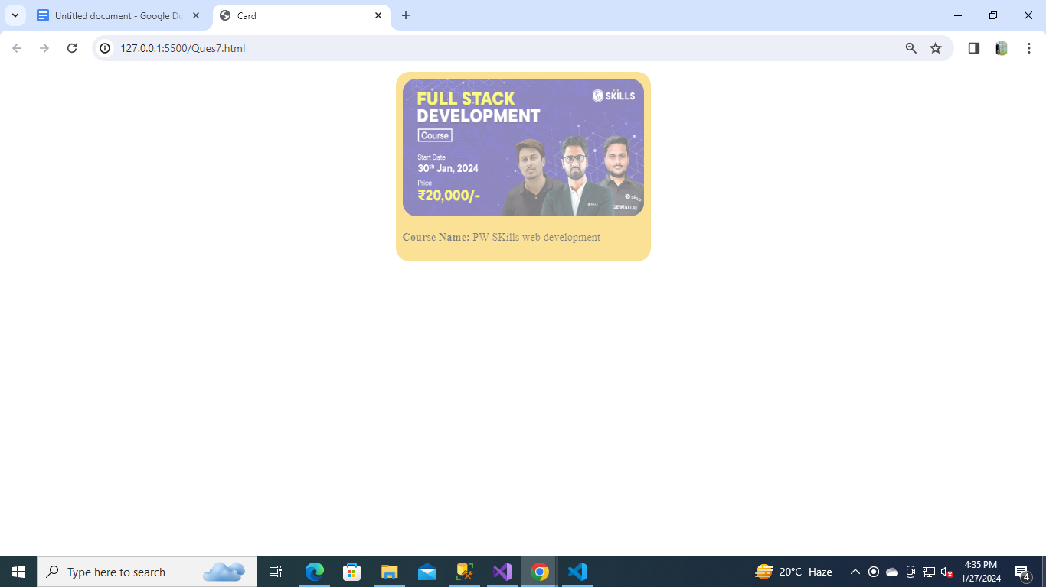

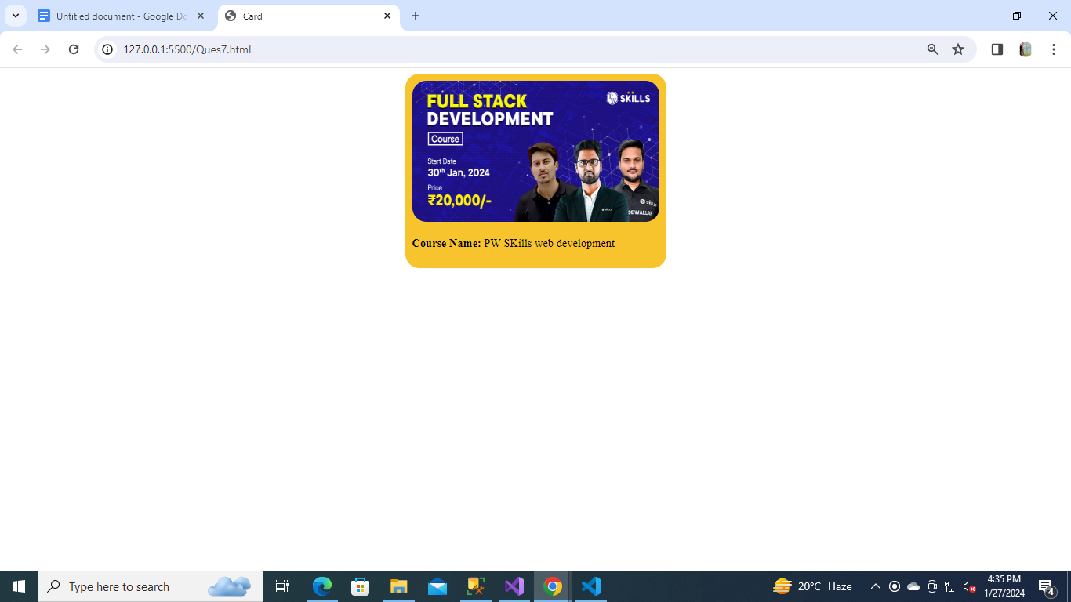

**8) Create a simple list of items as mentioned in the below image.**

**Solution:-**

**<!DOCTYPE html>**

**<html lang="en">**

**<head>**

**<meta charset="UTF-8" />**

**<meta http-equiv="X-UA-Compatible" content="IE=edge" />**

**<meta name="viewport" content="width=device-width, initial-scale=1.0" />**

**<title>List Items</title>**

**<style>**

**li {**

**list-style-type: lower-roman;**

**}**

**</style>**

**</head>**

**<body>**

**<h1>Requirements</h1>**

**<ul>**

**<li>System with minimum i3 processor or better.</li>**

**<li>At least 4 GB of RAM.</li>**

**<li>Working internet connection.</li>**

**<li>Dedication to learn</li>**

**</ul>**

**</body>**

**</html>**

**OUTPUT:-**

